Fairchild Reservation Systems

Business Requirements Document

Version 1.0

Copyright 2011 Alex Fairchild

Revision History
Author | Version | Date | Description
Alex Fairchild | 1.0 | June 19, 2011 | Initial version

Table of Contents
Table of Contents 2
Introduction 2
Requirements 2
Home Page 2
Flight Search 3
Availability Display 3
Hotels 4
Contact 4
Confirm 4

Introduction
This document defines the business Requirements for the Aairchild Reservation System. It will be a simple, web-based Airline and Hotel reservation system, that will allow a user to search for flight availability, make a reservation, and add hotel stay.

Requirements

Home Page
The home page will show a header with the company logo. Look will be clean, blue and white palette. Helvetica and bubbly. There will be a search box on the upper left. To the right of the search will be a box showing a Route Map, with all possible routes between San Francisco , Miami, New York, and Santo Domingo. The routes will thicken and darken as the flights are selected on the search screen.
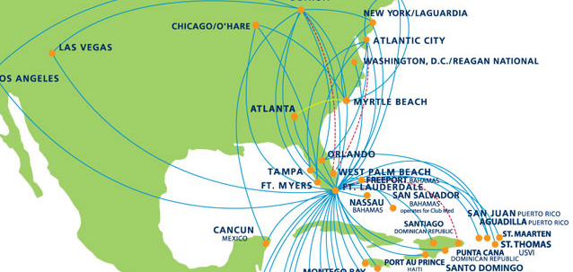

Across the top is a progress bar of where you are in the Reservation flow
Flights | Hotel | Contact | Confirm

Flight Search
On the upper left there will be a search box, which will have 2 pulldowns for departure and arrival city, 2 calendars for dates, and a checkbox to select One Way or Round Trip
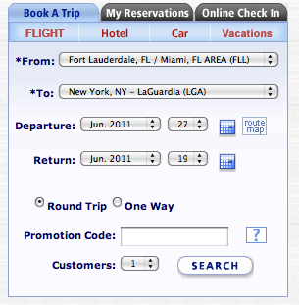

Availability Display
After the user hits submit, the map display area changes to an availability of the Outbound flights. For the Avail itself, there are tabs across the top showing 3 days back, and 3 days forward, with the cheapest fare on that date displayed. Below the tabs will be a list of flights, each showing 2 prices, a Coach and a First Class. 3 flights per city pair, Morning, noon, and Evening.
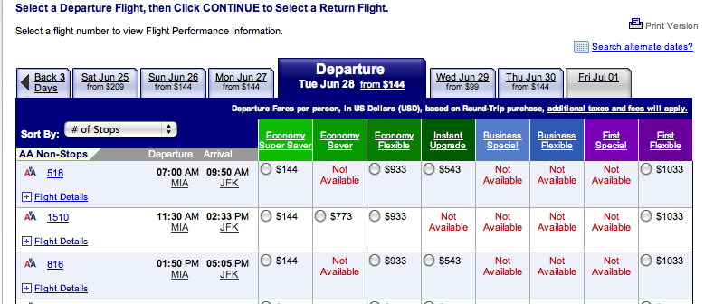
The user will select a fare and date, which will activate the ‘next’ button. They will click ‘select return flight’. The display will fade in and out and show the same thing with the returns. The user will again select a flight and fare, and the continue button shows up.

Hotels
There is a pop up before selecting hotels, asking if you want to add or not. If yes, then the display changes to a list of hotels. 4 hotels per city pair, a pretty picture, star rating, cost per night, and total cost. There is a skip hotel button which is enabled. If they pick a hotel, a ‘Next’ button gets enabled.

Contact
Next the display changes to a Profile info. At the top we have the charges so far; base fare, taxes , fuel surcharge, hotel reservation cost. There are Name, Last name, telephone number, email address, sex, birthday collection fields. Error validation of the required fields will be enabled.

Confirm
Nex the Itinerary, Hotel, and contact information are displayed in three sections, each with a small ‘change’ button next to it. Clickin on any will take the user back to that section. Going back to Flight Selection and changing dates will discard the Hotel, so it will have to be reselected, but once they pick a hotel again the system goes back to the confirmation page with the same profile data, we are storing it in the DB as we go.

Below the sections to review, will be a form of payment selection, where you enter a fake credit card number,

Itinerary
When the user clicks confirm, they are taken to a nice printable itinerary with their all alpha PNR. How much they paid, and what the form of payment was, last four digits of cc. Some advice about getting to the airport 2 hours before flight time and have proper ID.

Maintenance
Ability to maintain schedules, pricing with security controls of employees.

Reports
Need a data wharehouse of metrics, look to book, financials

Documentation
Provide online help of every feature on the site

Quality
Builds to production must pass rigorous automated regression test of all features and known bugs.
Build an object oriented, robust, change resistant, easy to add to, Test Application mirrors the Customer Application at every step.
Error handling is enforced.
Builds are fast, simple, error free, automated, with 1-button rollback.

Performance
Data must be archived older than 60 days. System will have hooks for reporting performance at every step and be visible to team – reducing performance bottlenecks is a constant priority.
System won’t die because a machine goes down, any machine immediately failsover to a new, perfect clone – with 1-button.

APIs
System can interface via TypeB in/out. TypeA in/out. DCS PFS/PNL in out.
APIs to the system are non-propietary, OTA for XML.

